 

**Placement Empowerment Program**

***Cloud Computing and DevOps Centre***

**Create a Simple Backup Script**

Create a script that backups up your entire Git repository to a local folder daily

Name: Harivasan S

Department: ADS



**Introduction:**

Frequently backing up Git repositories protects against data loss. This guide demonstrates how to create a straightforward script using tar for Linux/macOS or robocopy for Windows to automate daily backups. The backups will be scheduled using cron on Linux/macOS or Task Scheduler on Windows for seamless automation.

**Objectives:**

1. Automate daily backups of Git repositories stored in a local folder.
2. Use tar for Linux/macOS and robocopy for Windows via shell or batch scripts.
3. Maintain up-to-date repository copies to improve data security and prevent loss.
4. Schedule backups using cron on Linux/macOS or Task Scheduler on Windows.
5. Minimize manual effort while ensuring efficient and reliable repository protection.

**Step by Step Overview :**

Step 1 :

Choose Your Backup Location

Decide where you want to store your backup files.

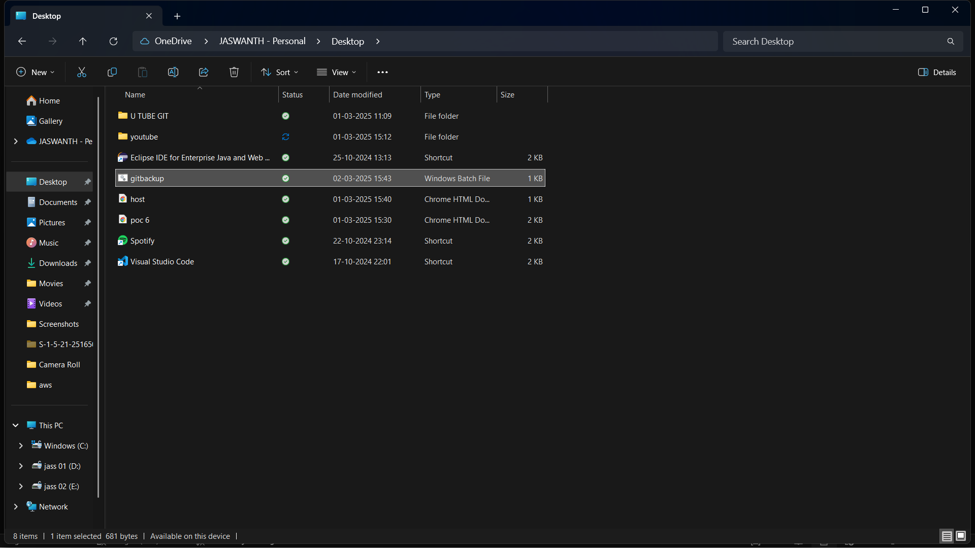

Step 2 :Create the Backup Script and save the script as .bat format ex: gitbackup.bat

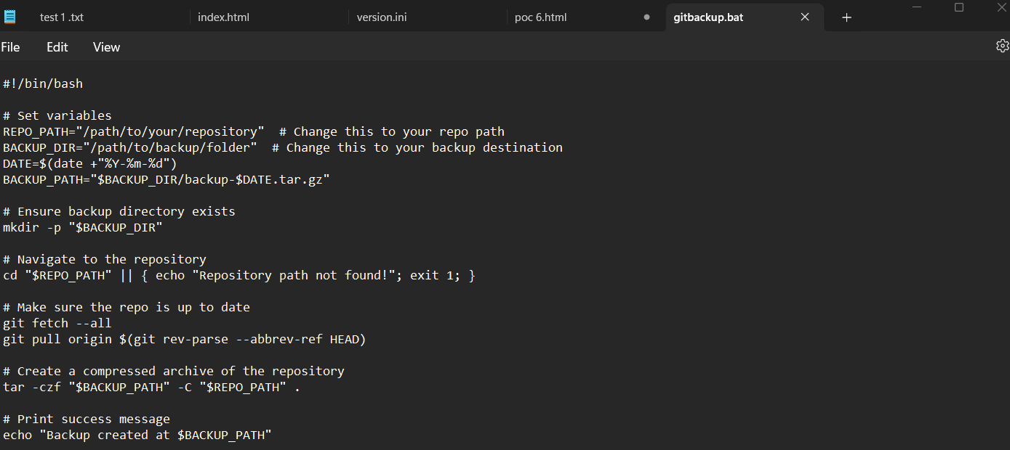

Step 3:

Open Task Scheduler:

* + Press Win + R, type taskschd.msc, and hit Enter.

Step 4:  
Create a New Task:

* + Click **"Create Basic Task"** in the right panel.

Name it **"Daily Git Backup"** and click **Next**

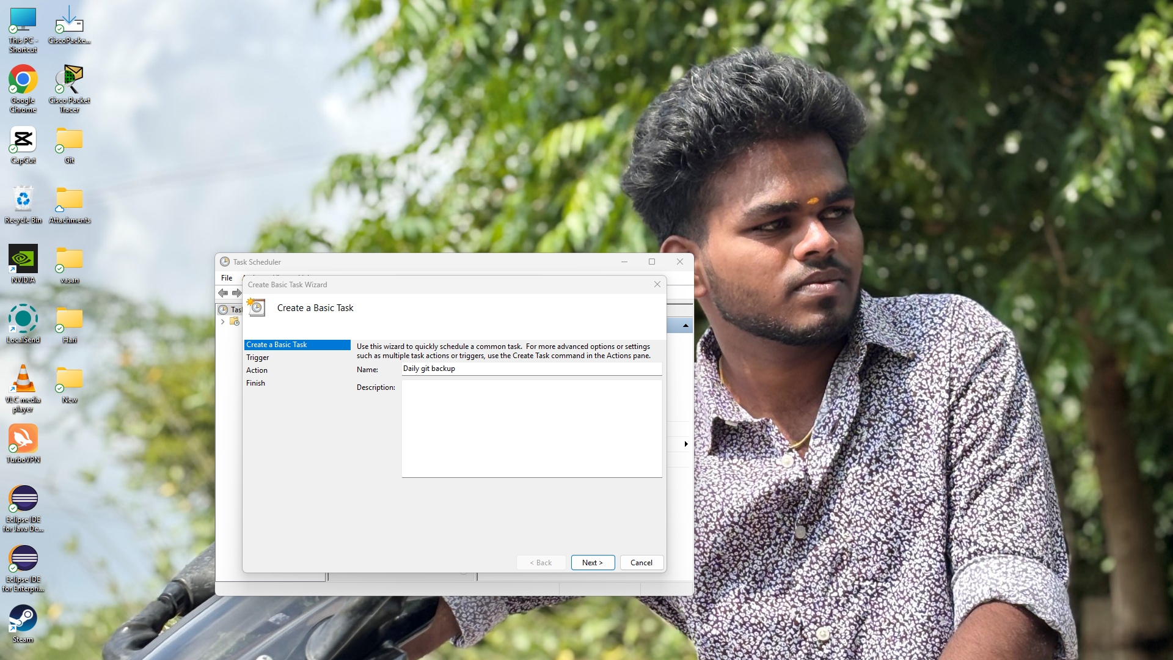

Step 5:

Set Trigger (Daily Execution):

* + Select **"Daily"**, set a preferred start time, and click **Next**.

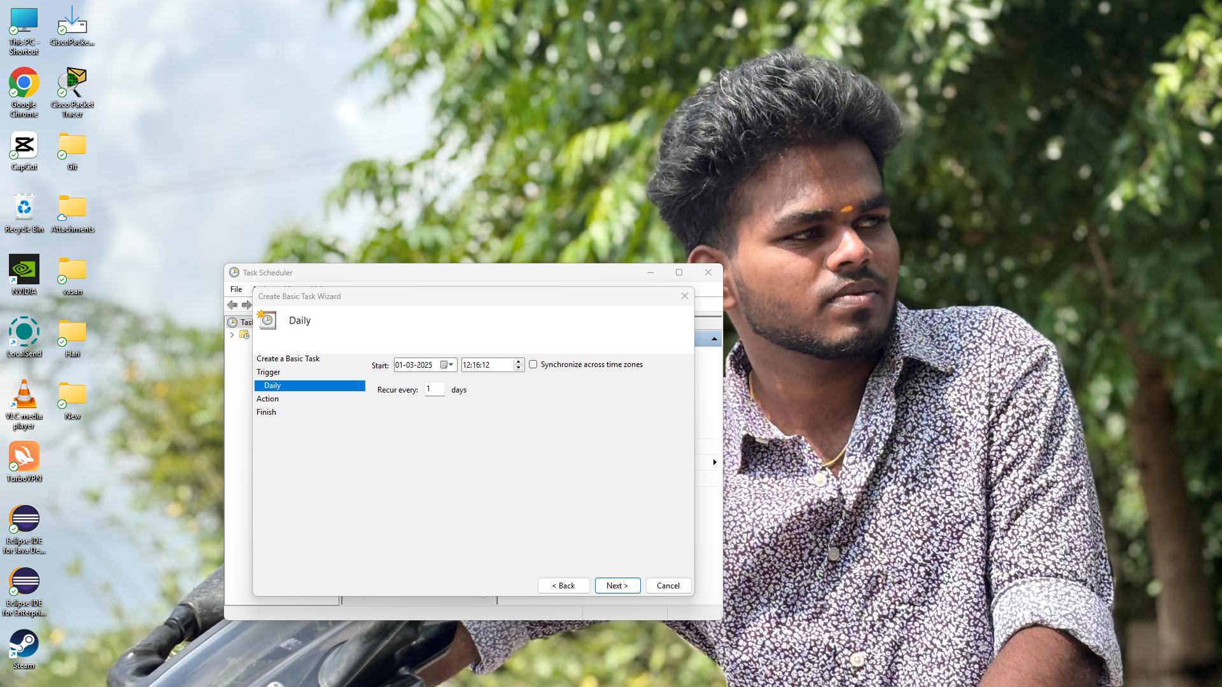

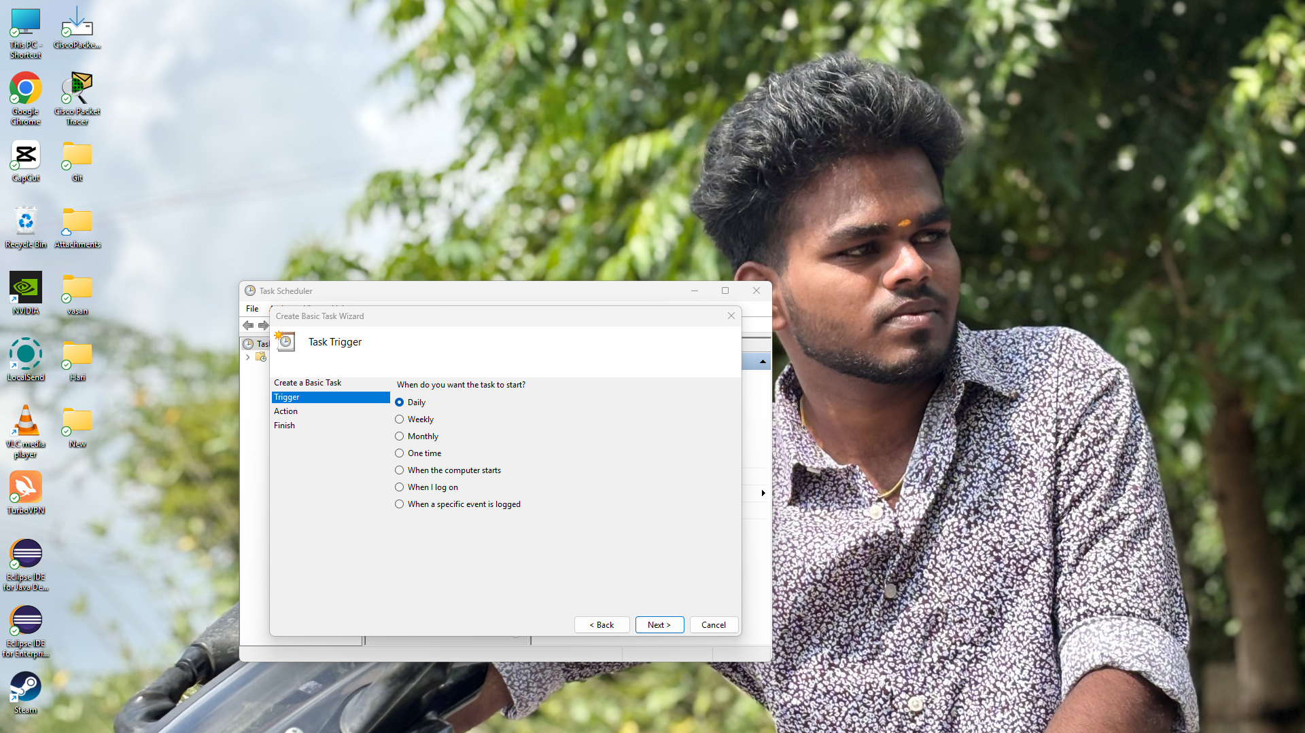

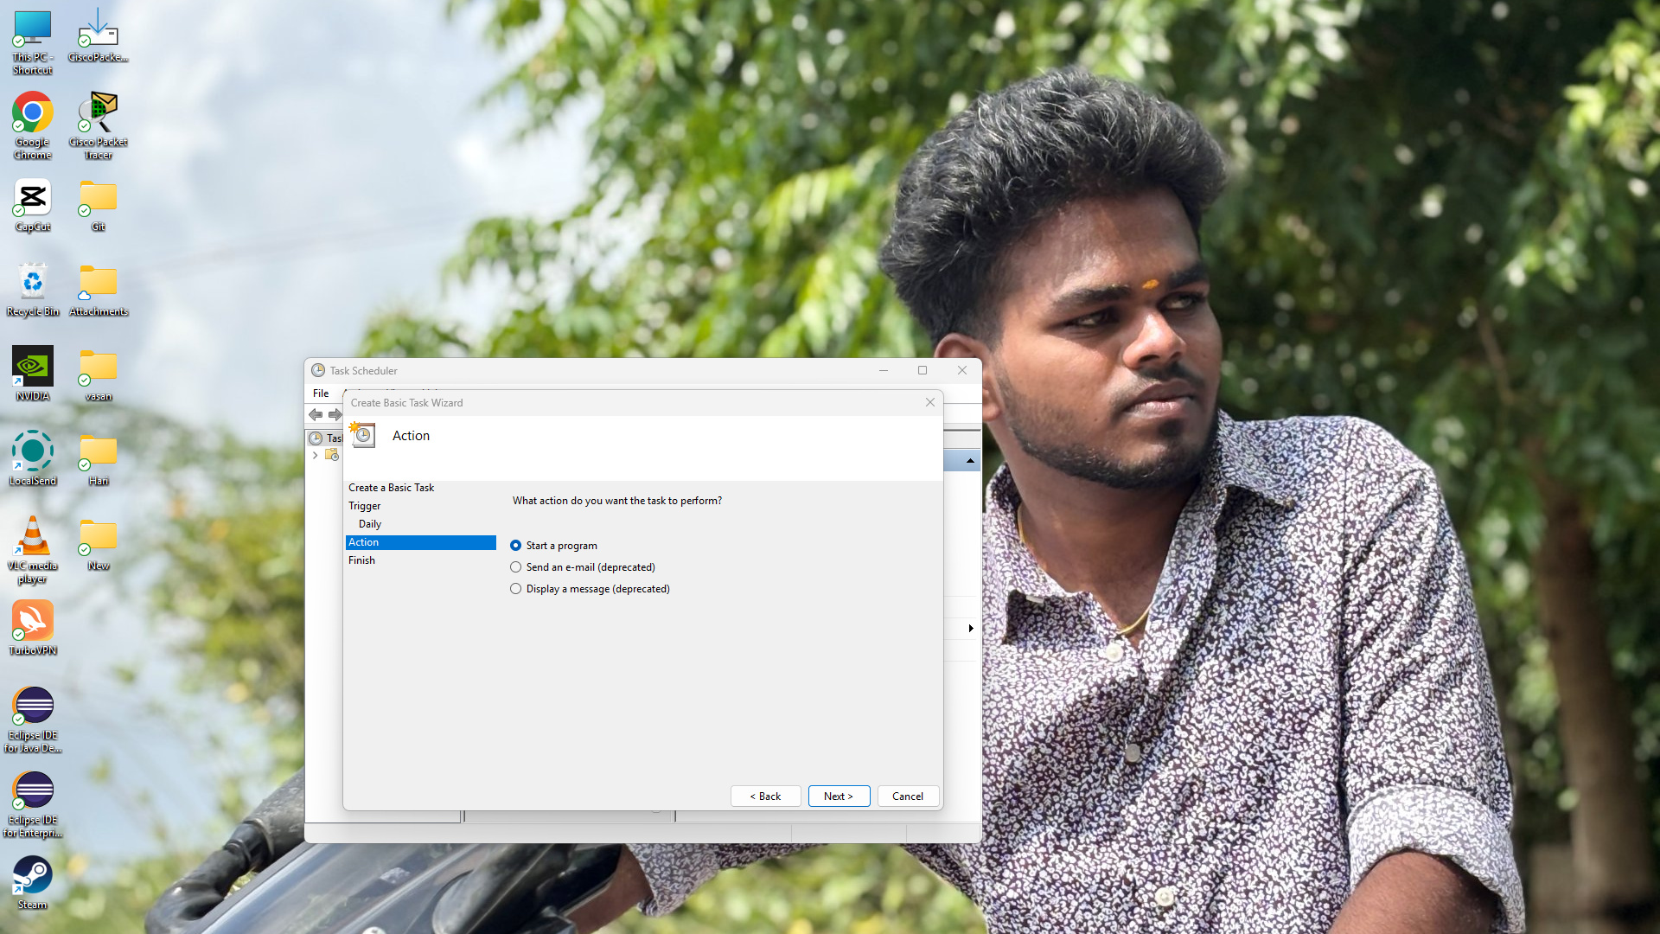

Step 6:

In this step assign the name as daily git backup and finish the process.

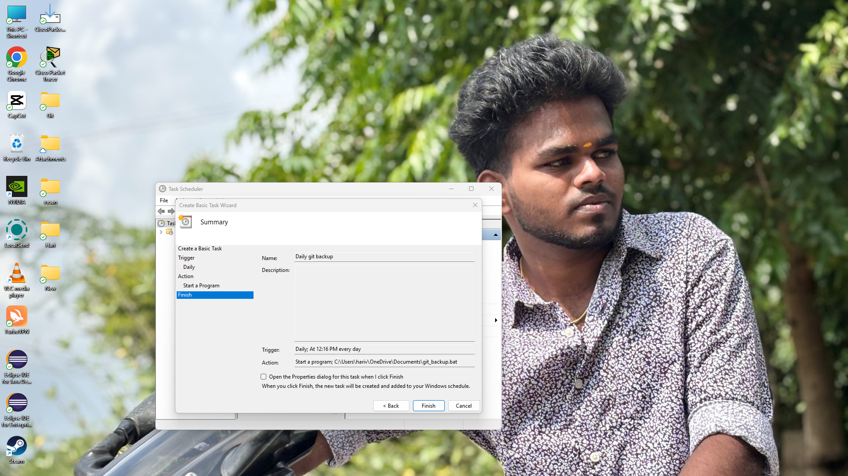

Step 7:

**Verify Your Backups**

* Open the backup file to confirm that contains your Git repository in that file.

**Expected outcome:**

1. **Automated Daily Backup:** The script creates a daily backup of the entire Git repository in a local folder.

2.**Scheduled Execution:** The process runs automatically using cron (Linux/macOS) or Task Scheduler (Windows).